COMP306 – Assignment 5
David Harris
300069566

Problem 3.22
TCP avoids measuring the sampleRTT for retransmitting segments because the SampleRTT will then be too short. The problem arises when in the situation shown below, it is not known if the ACK received is from the original transmission or the retransmission. This is illustrated below (The picture is taken from the http://www.ssfnet.org/Exchange/tcp/tcpTutorialNotes.html)
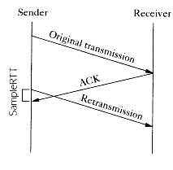
Problem 3.25
This is because if three packets are lost, it is more likely that there is a problem with the medium, and if packets are transmitted after only one duplicate ACK, then a lot of time will be spent sending un-needed data. The possibility of missing one ACK is high as packets can quite easily go astray in the internet, but the chances of missing three is much lower under normal conditions.

Problem 3.27
- Slow start is 1-5 and 23-25 (inclusive)
- Congestion avoidance is 6-16 and 17-22 inclusive.
- Triple duplicate ACK
- Timeout
- At the first transmission round, Threshold is 32KB
- At the 18th transmission round, Threshold is 21KB
- At the 24th transmission round, Threshold is 13KB
- The 70th segment is sent in the 7th round
- CongWin: 4, Threshold: 4

